**10 Module Description**

**BLOOD DONATION**  is a website based on PHP. The purpose of this project was to develop a blood management information system to assist in the management of blood donor records and ease or control the distribution of blood in various part of country basing on the hospitals demand. . This project includes mainly two modules i.e. login and main page.

* **Login:**

**10.1.1** **Admin**

**10.1.2 User**

**10.1.Admin:** The page require user name and password to start the application. Login is a process by which individual access to a computer system is controlled by identifying and authenticating the user through the cardinalities presented by the user. Admin can add update or delete the user, city, state, camp etc.

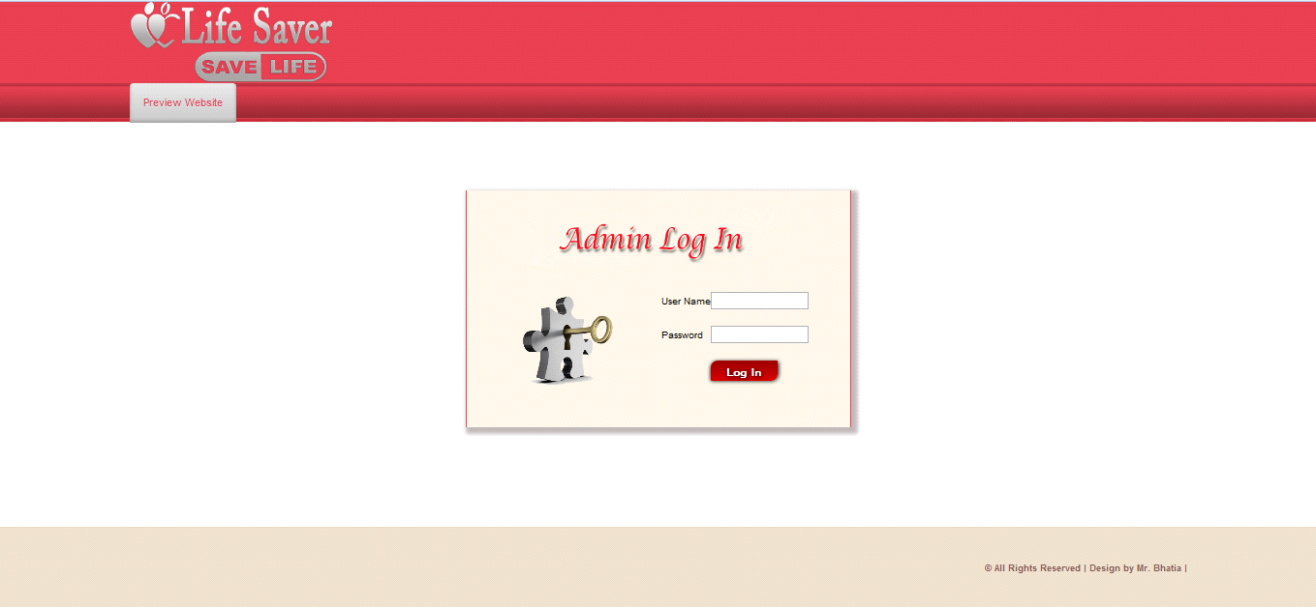

**10.2 User:** User can register the account by fill the information about you and click on save button. He/she can add the account for the further enquiry of the blood donation. The user have to login to get more information about the blood bank.

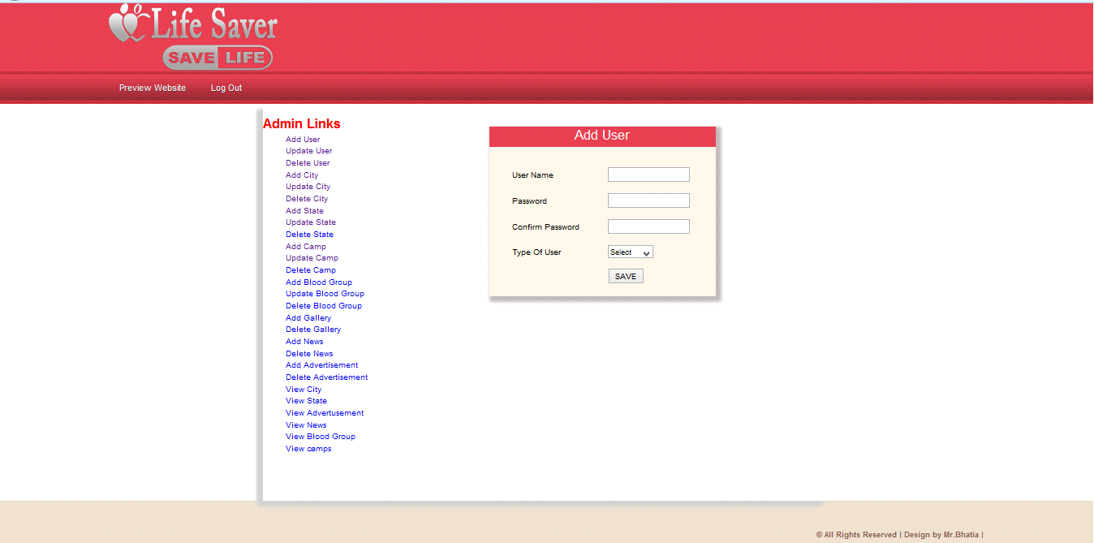

**Admin are of a two type:**

10.2.1 Admin level user

10.2.2 General level user

**10.2.1 Admin level user:**

Admin level user are a admin user, if he/she login a admin panel they work on a all the pages of the admin site like add user, update user, delete user, add city, update city, delete city etc.

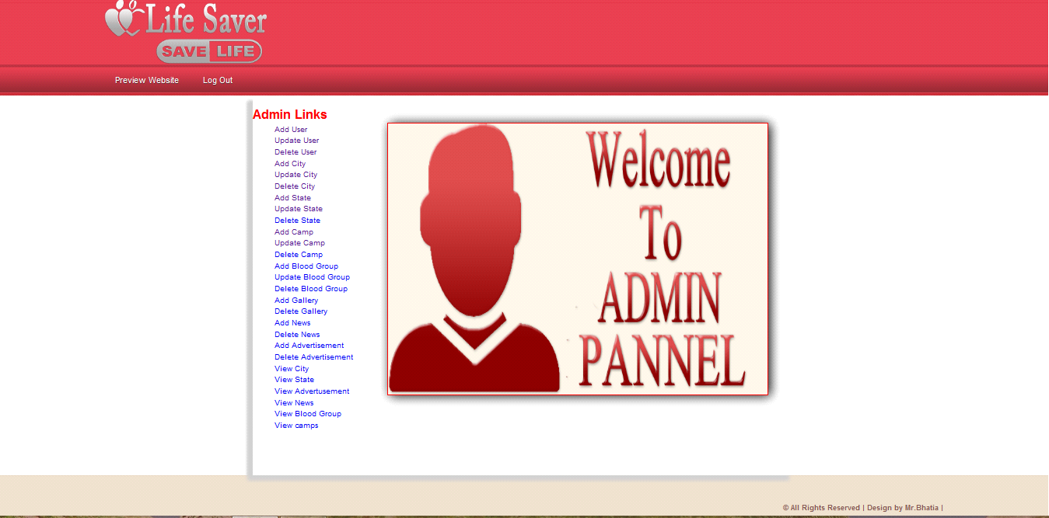

**10.2.2 General level user:**

General level user are a general user, if he/she login a admin panel they don not see all the pages of the admin site like add user, update user, delete user, add city, update city, delete city etc. They work on only a addition of the new user, city, state, camp etc.

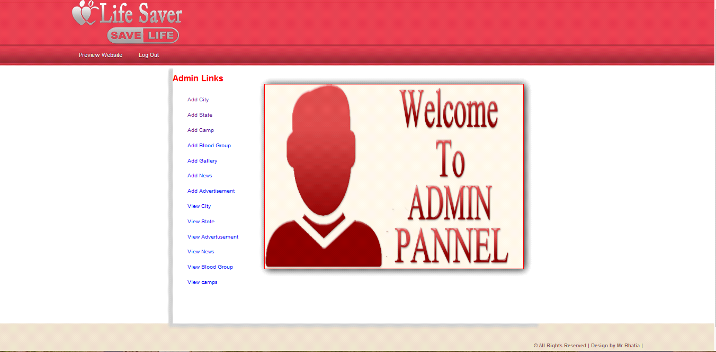

* **Main Page:**

10.3.1 Main Window

* Registration Page

10.3.3 Donor login

**10.3.1 Main Window:-** The BLOOD BANK MANAGEMENT SYSTEM is great project. this project is designed for successful completion of project on blood bank management system. the basic building aim is to provide blood donation service to the city recently. Blood Bank Management System (BBMS) is a browser based system that is designed to store, process, retrieve and analyze information concerned with the administrative and inventory management within a blood bank. This project aims at maintaining all the information pertaining to blood donors, different blood groups available in each blood bank and help them manage in a better way.

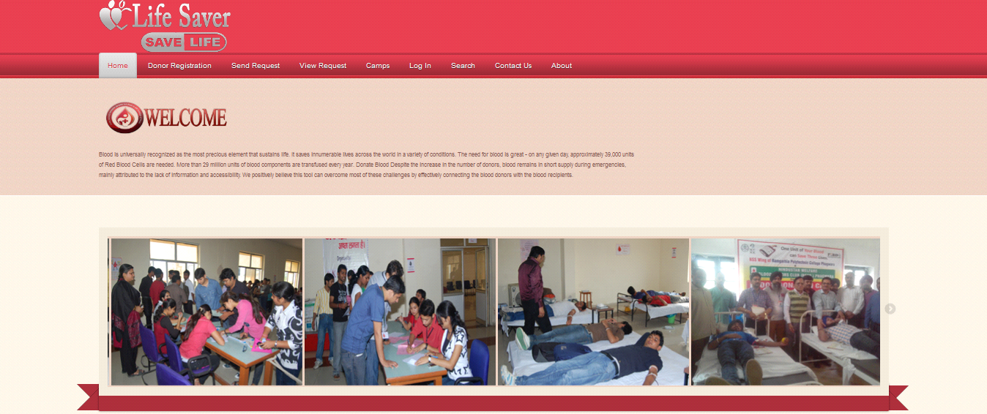

**10.3.2 Registration Page:** Registration page includes the information of the donor who want to register. Donor can register the account by clicking on new register. He/she can add the account for the further enquiry of the blood donation.

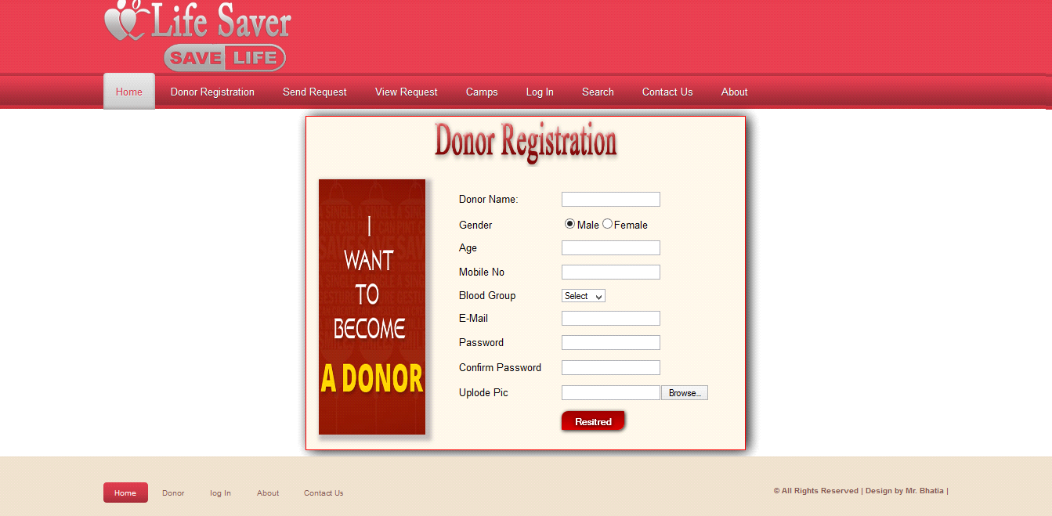

**10.3.3 Donor login:-** The page require donor id and password to open the donor pannel. Login is a process by which individual access to a computer system is controlled by identifying and authenticating the user through the cardinalities presented by the user. Donor can change password, update profiile or view donations etc.

